

**KAUNAS UNIVERSITY OF TECHNOLOGY**

**FACULTY OF INFORMATICS**

**COMPUTER DEPARTMENT**

### App Development for Smart Mobile Systems Individual work

**„Morse code flashlight translator“/“Morsify“**

**Assignment completed by:**

IFF 6/8 group student

Tadas Laurinaitis

**Assignment evaluated by**:

Prof. Rytis Maskeliūnas

Table of contents:

Description of app: The application which I am creating is a tool used to translate written text to morse code and then show it using flashlight. User will be able to write a sentence, which then will be translated into morse code (dots and dashes) and will have an option to communicate that code using camera‘s flashlight. User will also have an option to see information about application, change application‘s settings and will be able to close application using „Exit Application“ button.

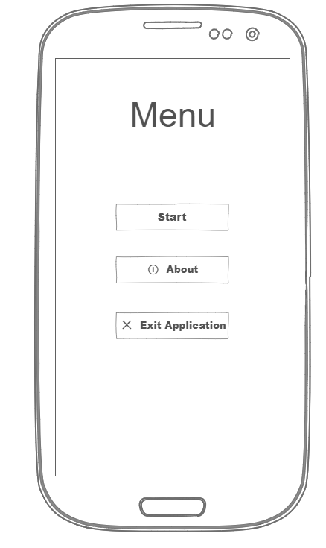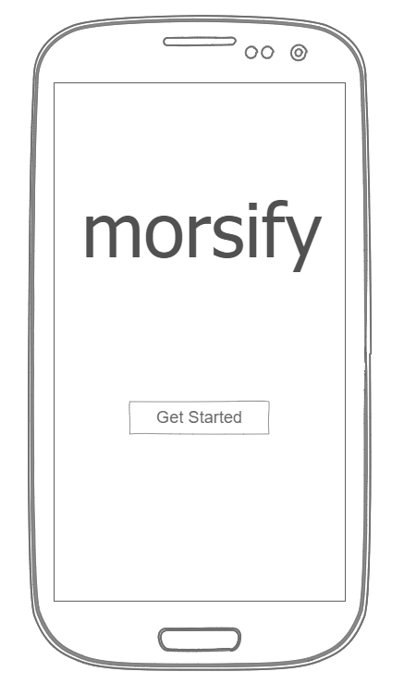App mockup:

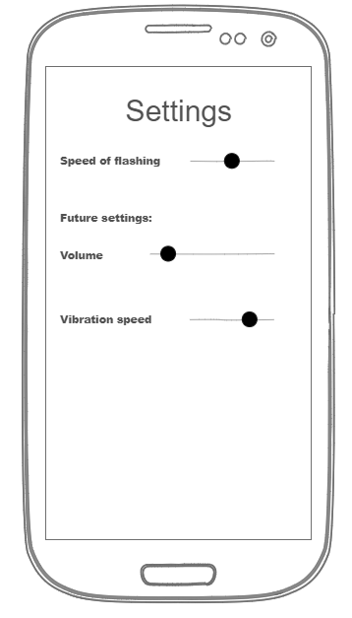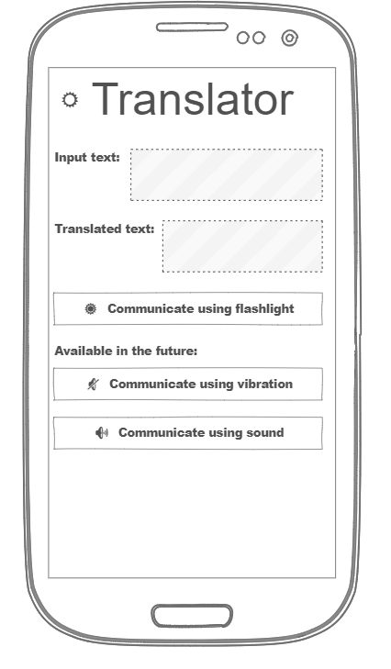

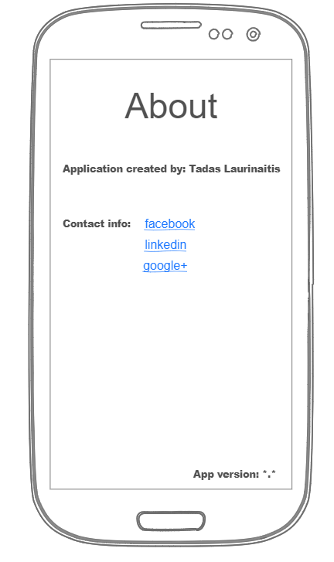

Literature:

<https://ninjamock.com/> - for mockup creation